

****Asset Operations User Manual

**System Login**

For starting the Asset workflow process, Firstly user CSO/CS User have a login ID from Admin user. User will login with respective Login ID. Sample page are given below. Input User ID and Password in User ID and Password field. Click on Sign In button.

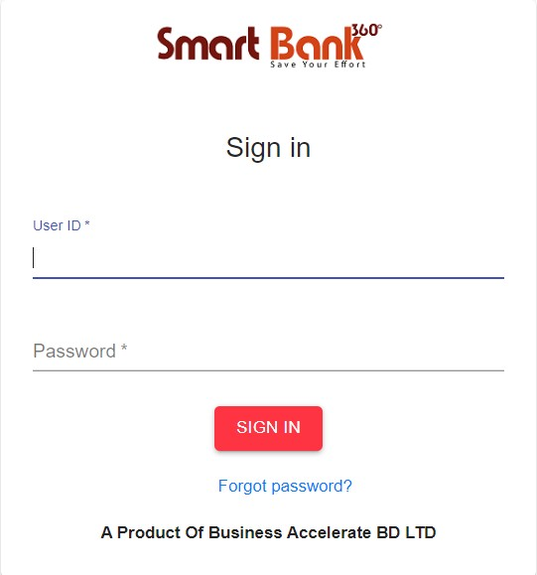

**Asset Operation:**

After login these Page will appear. We have to click **Asset Operation** and then **Service Request**

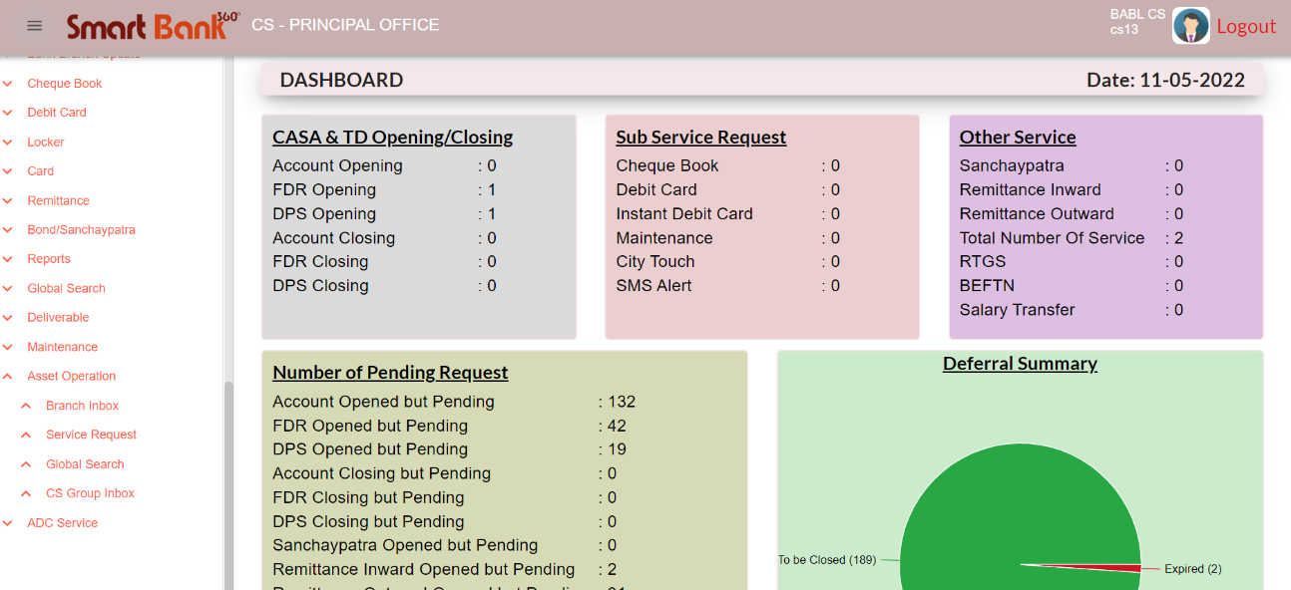



Service Request

Asset Operation

****Closing Request (Other than Secured Loan)

**Service Request:**

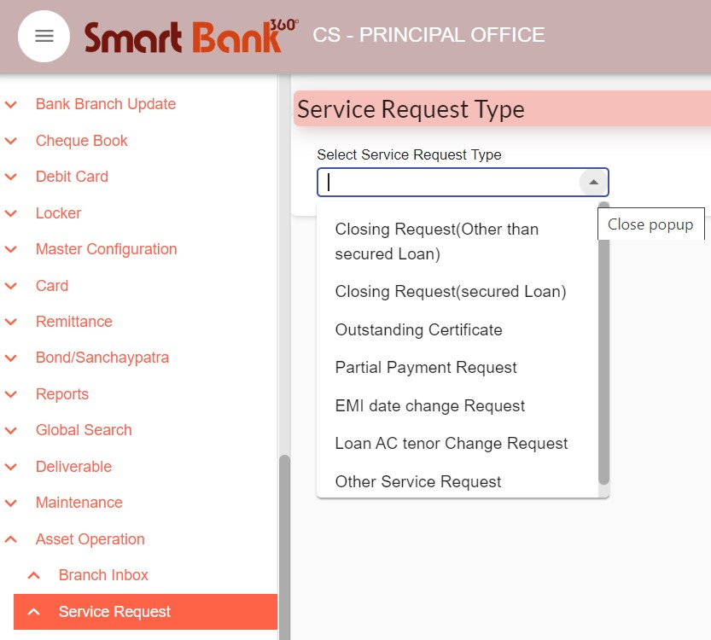After clicking **Service Request** user will get a dropdown bar. From there user can select AWF Service Request Type

**CS View**

Each Request will initiate from CS group. User need to input CB (Customer unique number) to generate other require information.

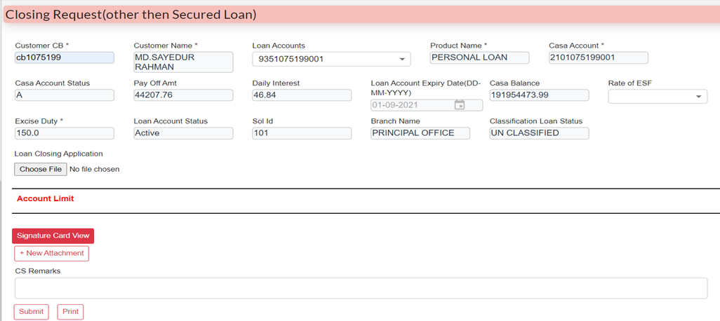****Here, user can add attachment and Print client details, after fill-up all the required fields. Click **Submit** button to forward the case from **CS to BM**

After Logged in **BM**, Case will be found at Branch Inbox Need to lock from **Group Inbox** then the case will be open from **Self-Inbox**

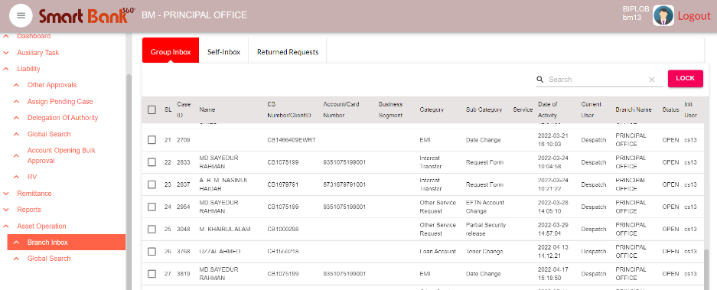

**BM View**

If **BM** Click **Submit** button then the case will be forwarded to **Closing Checker** flow, If click **Return** then the case returned to **CS**

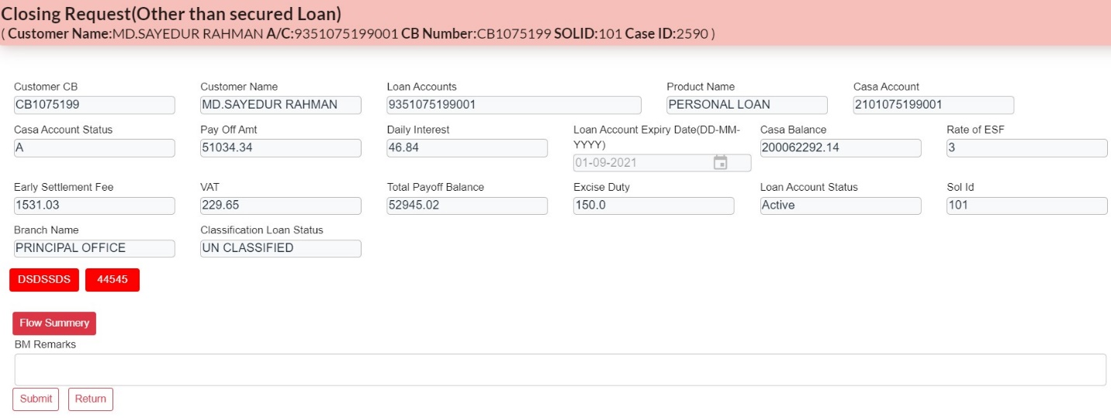



**Closing Checker View**

After logged in **Closing Checker** with the ID & Password, Same as **BM** procedure, lock the case from Group Inbox and open it from Self Inbox.

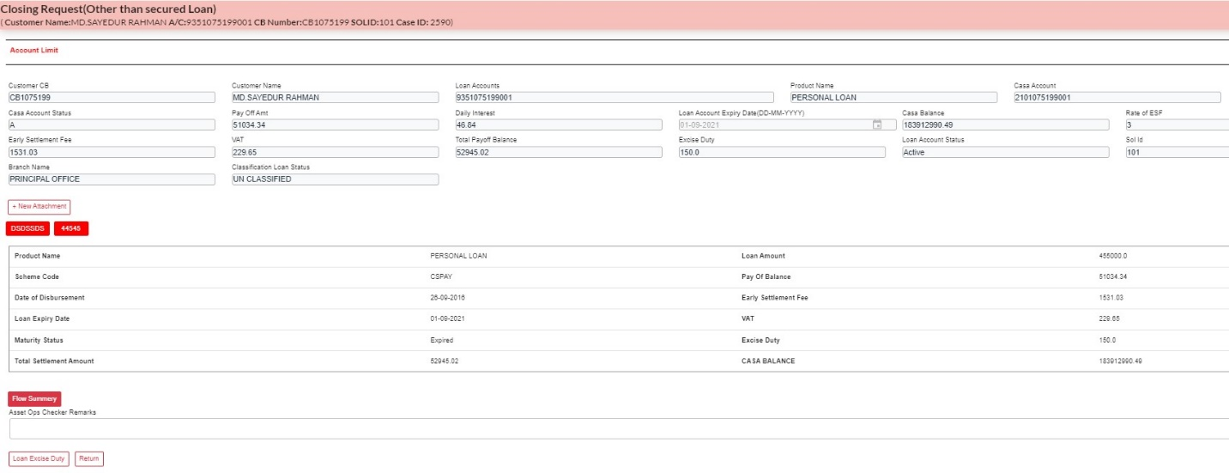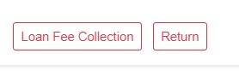In closing Checker end after clicking **Loan Excise Duty & Loan Fee collection** automatic deduction of charges and closing transaction will happen. Here User can add attachment and download previous attachment then click **Submit** to forward the case **closing checker** to **NOC Maker**. If click **Return** then the case returned to **BM.**

**NOC Maker View**

After logged in **NOC Maker** with the ID & Password, Same as **BM** procedure, lock the case from **Group Inbox** and open it from **Self Inbox.**

****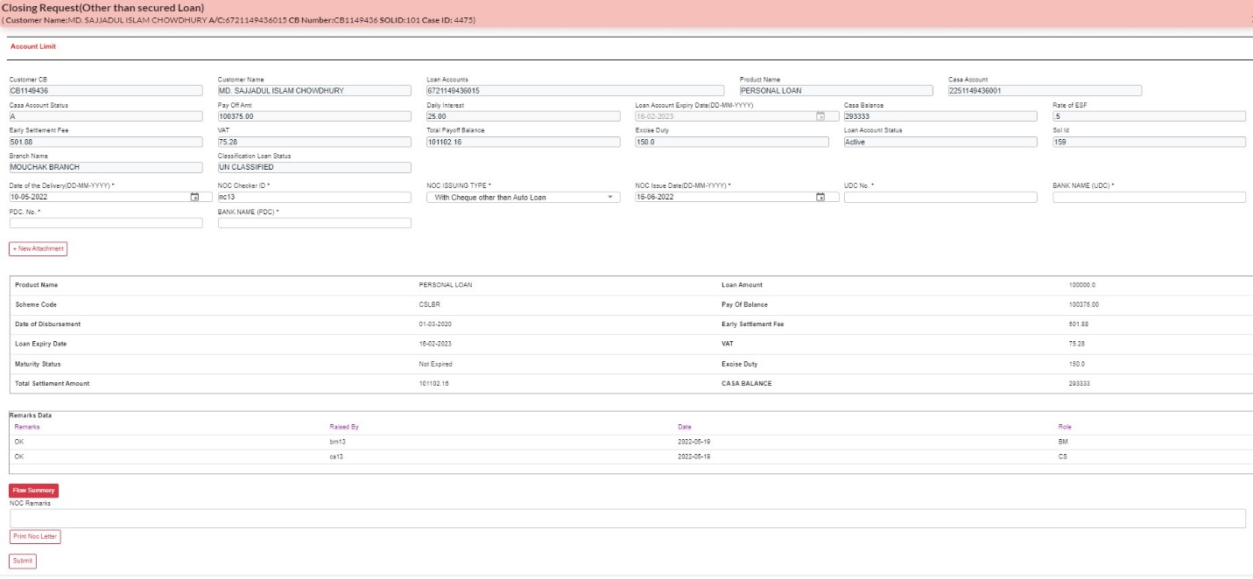In **NOC Maker** end user can add attachment and Print NOC letter. After Clicking **Submit** button case will be completed successfully.

Closing Request (Secured Loan)



**Closing Request (Secured Loan)**

After login in the system with required ID and Password user will select the **Closing Request (Secured Loan)** from the service request type.

**CS VIEW**

To initiate the case, User need to input CB (Customer unique number) to generate other require information.

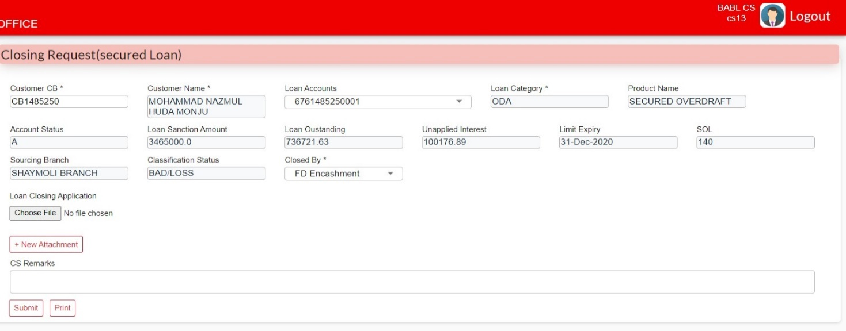Here, user can add attachment and Print client details, after fill-up all the required fields. Click **Submit** button to forward the case from **CS to BM**

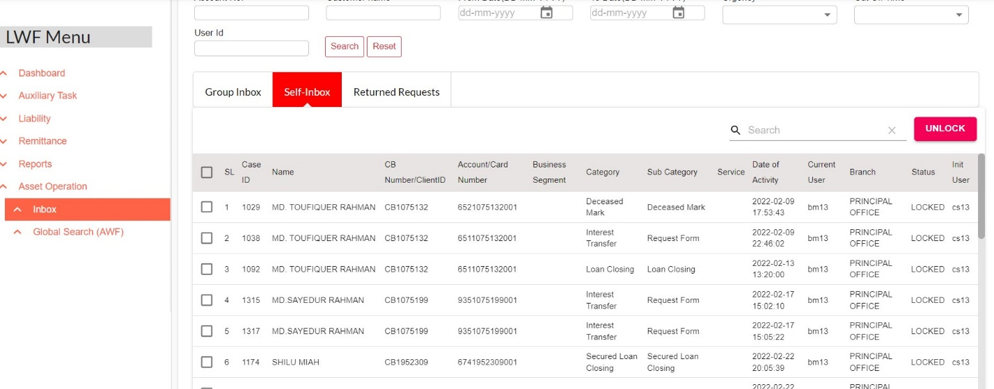After Logged in **BM**, Case will be found at Branch Inbox Need to lock from **Group Inbox** then the case will be open from **Self-Inbox**



**BM View**

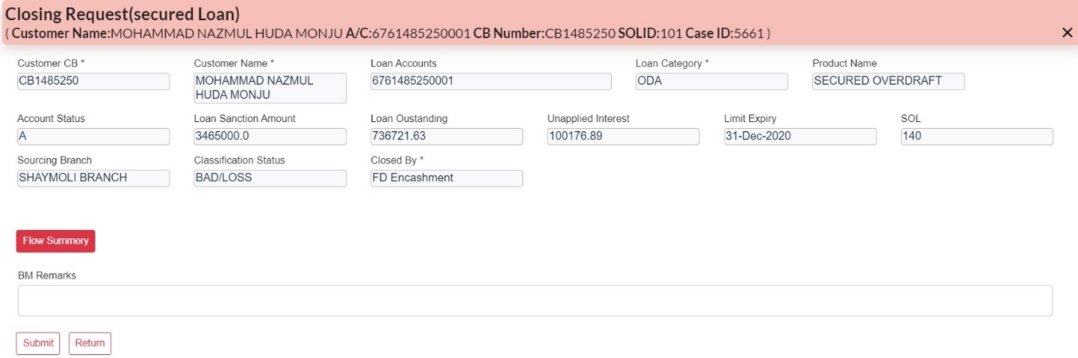If **BM** Click **Submit** button then the case will be forwarded to **Closing Checker** flow, If click **Return** then the case returned to **CS**

**Closing Maker View**

After logged in **Closing Maker** with the ID & Password, Same as **BM** procedure, lock the case from Group Inbox and open it from Self Inbox.

****In Closing maker end user can add new attachment and after clicking **Submit** button user can forward the case to **CS** or **Return** the case to **BM.**

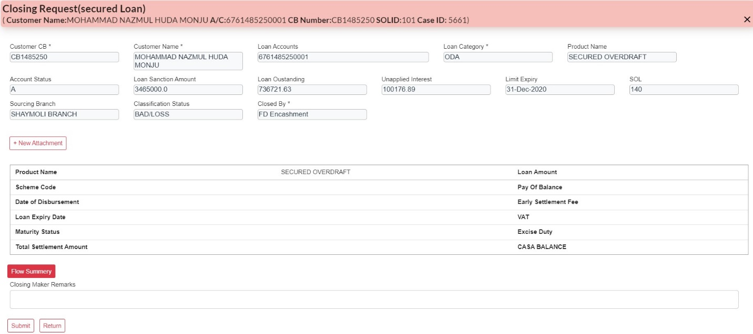

**CS view**

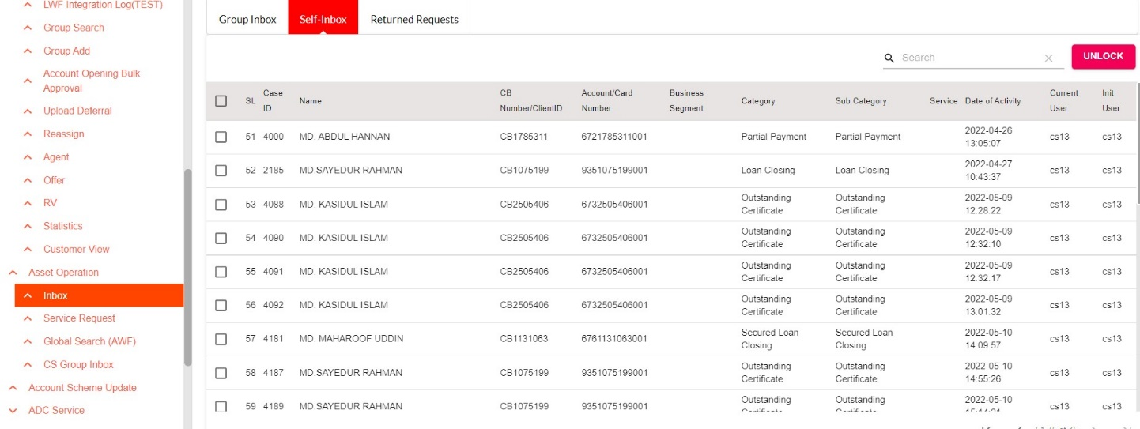After logged in **CS** with the ID & Password, Same as **BM** procedure, lock the case from Group Inbox and open it from Self Inbox.

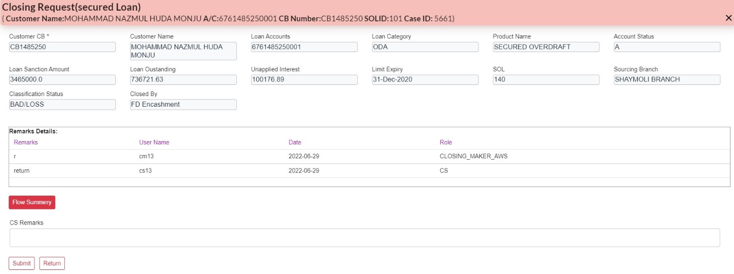****In CS end user can give comments/Remarks and then click **Submit** button user can forward the case to **BOM** or **Return** the case to **CM.**

**BOM View**

After logged in **BOM** with the ID & Password, Same as **BM** procedure, lock the case from Group Inbox and open it from Self Inbox.

In BOM end when user click Submit button then the case will be successfully completed.

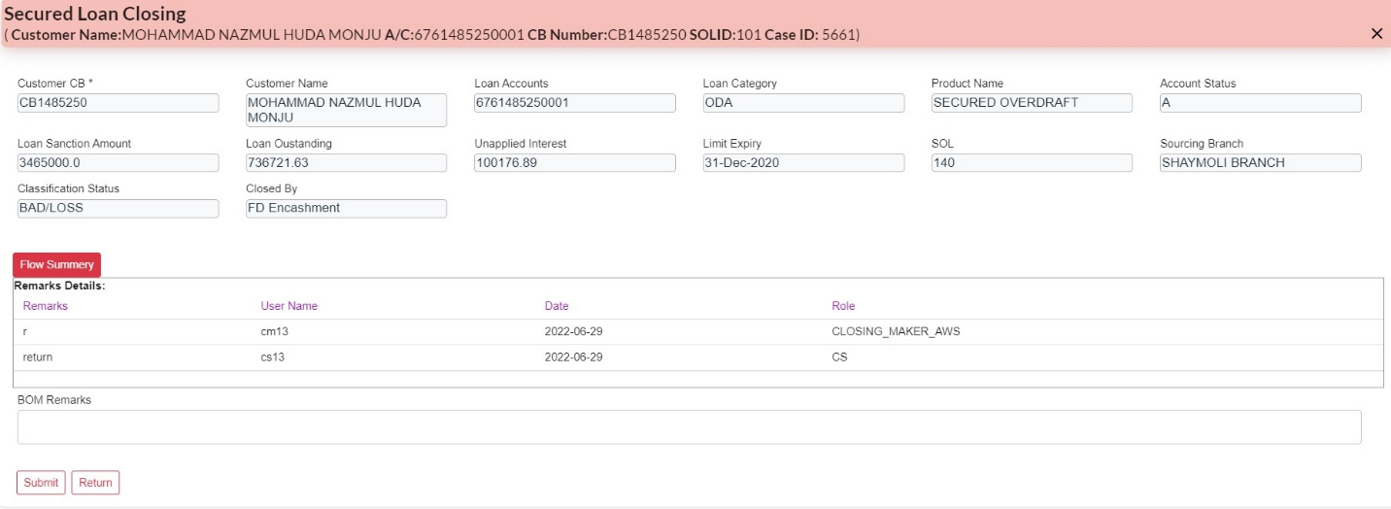



****Outstanding Certificate

**Outstanding Certificate**

After login in the system with required ID and Password user will select the **Outstanding Certificate** from the service request type.

**CS View**

To initiate the case from CS, firstly user will select required certificate from the certificate type (General, Tax Return Submission, and Take Over)

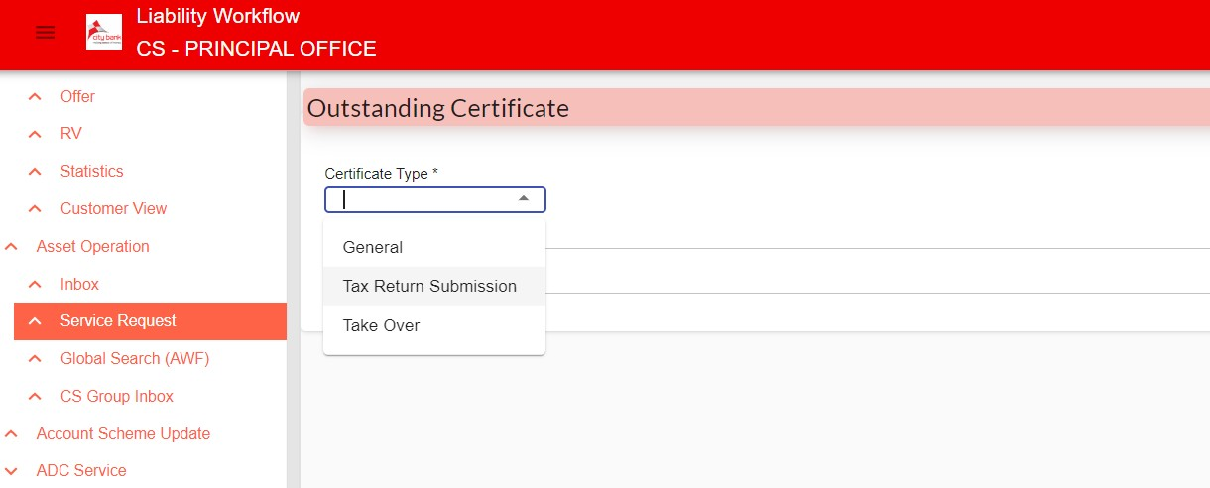

In terms of **Tax Return Submission**, User need to input CB (Customer unique number) to generate other require information.

****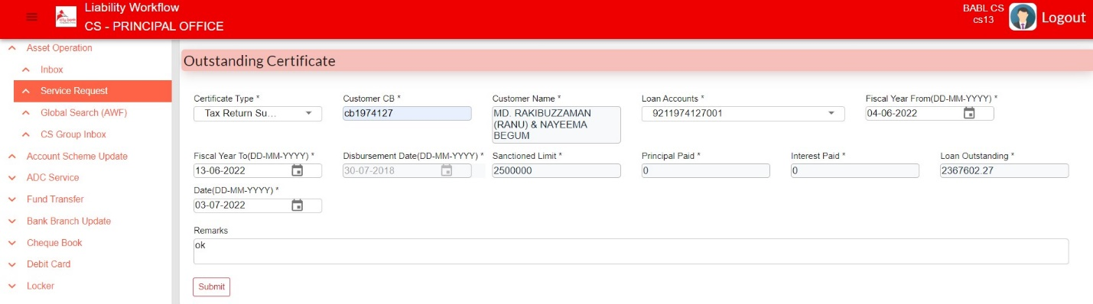After fill-up all the required fields. Click **Submit** button to forward the case from **CS to BOM**

**BOM View**

In BOM end User can check flow summary. Then Forward or Return the Case to CS.

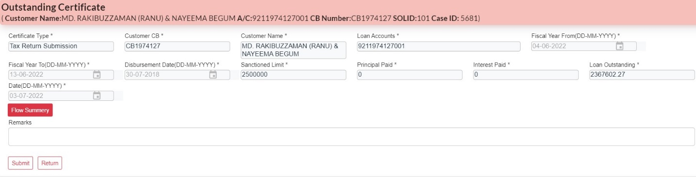

**CS View**

After logged in CS with required ID and Password user will get the case direct at Self Inbox.

User will open the case from self-Inbox and according to certificate type user will able to print the Outstanding Certificate. And then user can click Submit to close the case successfully.

Submit

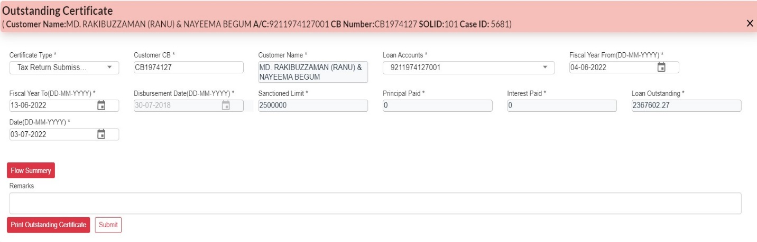

Print Outstanding Certificate

****Partial Payment

After login in the system with required ID and Password user will select Partial Payment request from the service request type.

**CS View**

To initiate the case, User need to input CB (Customer unique number) to generate other require information.

Here, user can add attachment and Print client details, after fill-up all the required fields. Click **Submit** button to forward the case from **CS to BM**

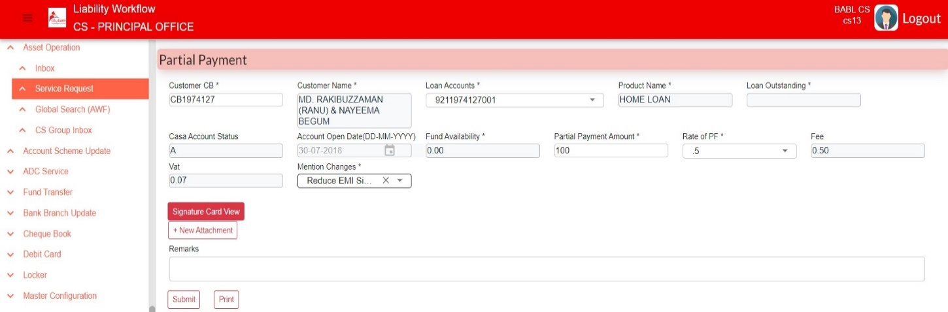

**BM view**

If **BM** Click **Submit** button then the case will be forwarded to **Disbursement Maker** flow, If click **Return** then the case returned to **CS**

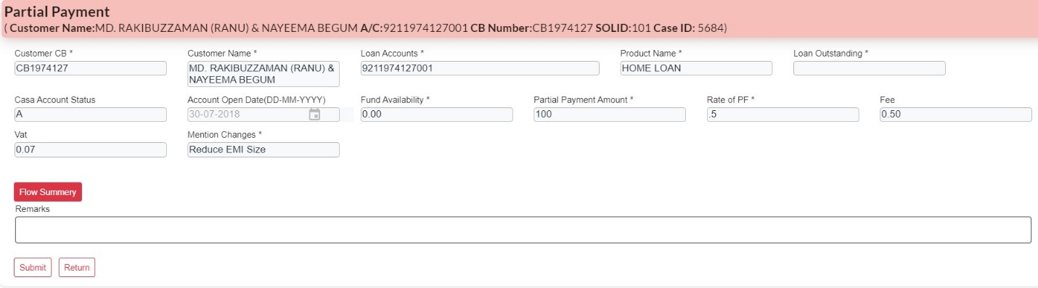



**Disbursement Maker View**

After logged in **Disbursement Maker** with the ID & Password, Same as **BM** procedure, lock the case from Group Inbox and open it from Self Inbox.

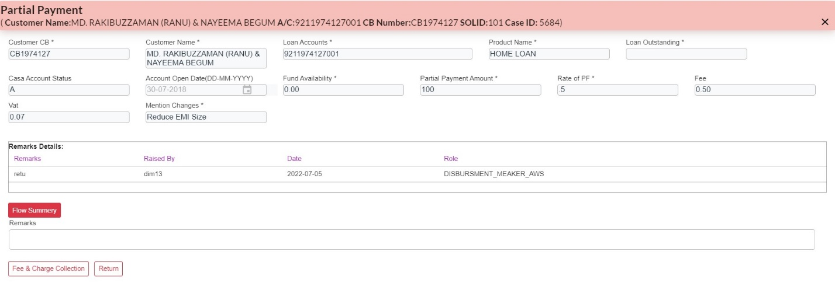In **Disbursement** **Maker** end if user click **Fee & charge collection** thenthe case forward to **Disbursement Checker** and or **Return** the case to **CS.**

Return

Fee & Charge collection

**Disbursement Checker View**

After logged in **Disbursement Checker** with the ID & Password, Same as **BM** procedure, lock the case from Group Inbox and open it from Self Inbox

In **Disbursement Checker** end when user click Submit button then the case will be successfully completed.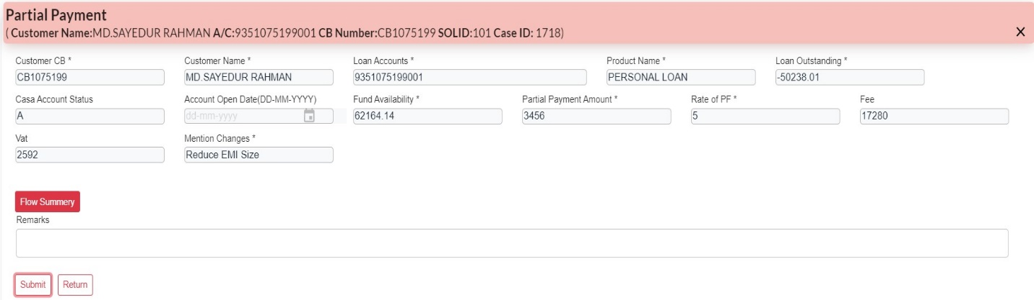

**Loan Account Tenor Change**

After login in the system with required ID and Password user will select Loan Account Tenor Change request from the service request type.

**CS View**

To initiate the case, User need to input CB (Customer unique number) to generate other require information.

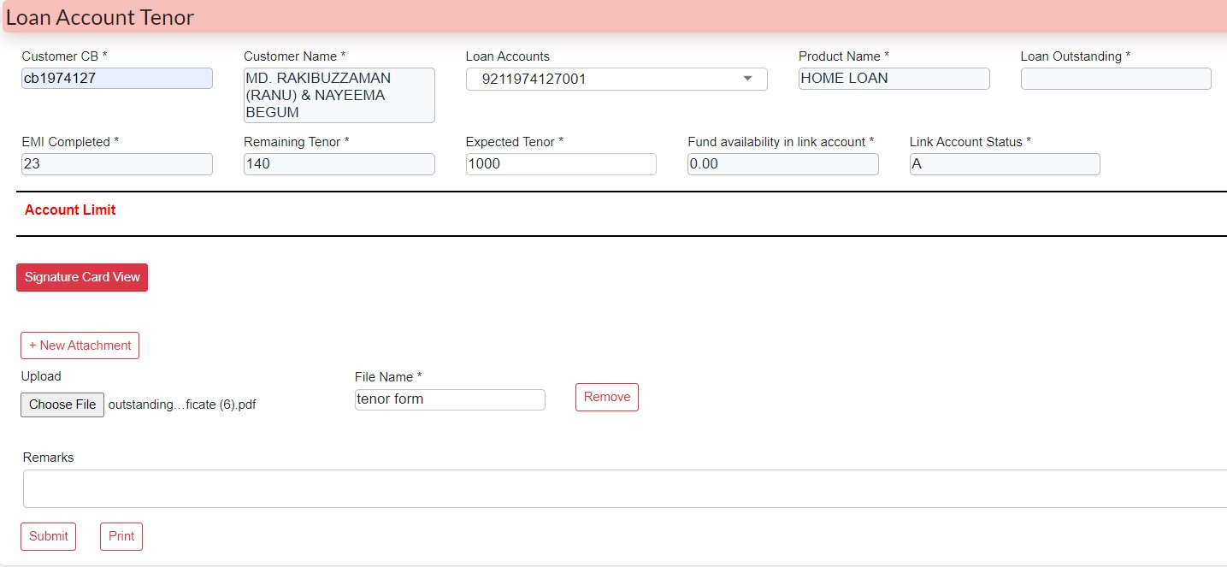Here, user can view signature card, can add attachment and Print client details, after fill-up all the required fields. Click **Submit** button to forward the case from **CS to BM**

**BM view**

**In BM end,** here user can attach file and view/download file ****if **BM** Click **Submit** button then the case will be forwarded to **Disbursement Maker** flow, if click **Return** then the case returned to **CS.**

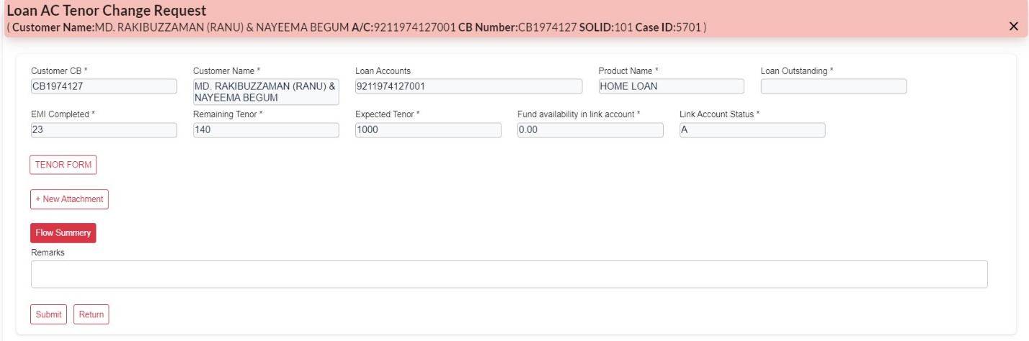**Disbursement Maker View**

After logged in **Disbursement Maker** with the ID & Password, Same as **BM** procedure, lock the case from Group Inbox and open it from Self Inbox.

****In **Disbursement** **Maker** end if user click **Submit** thenthe case will forward to **Disbursement Checker** if user click **Return** then the case returned to **CS.**

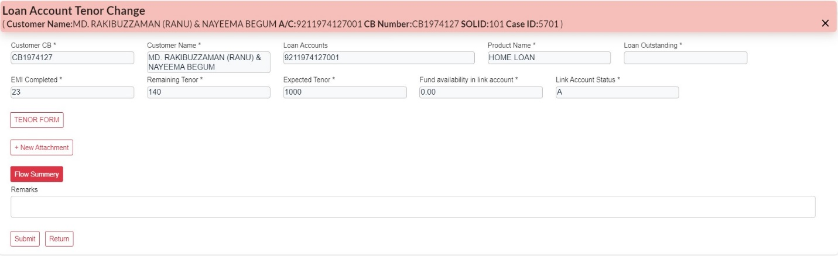

**Disbursement Checker View**

After logged in **Disbursement Checker** with the ID & Password, Same as **BM** procedure, lock the case from Group Inbox and open it from Self Inbox

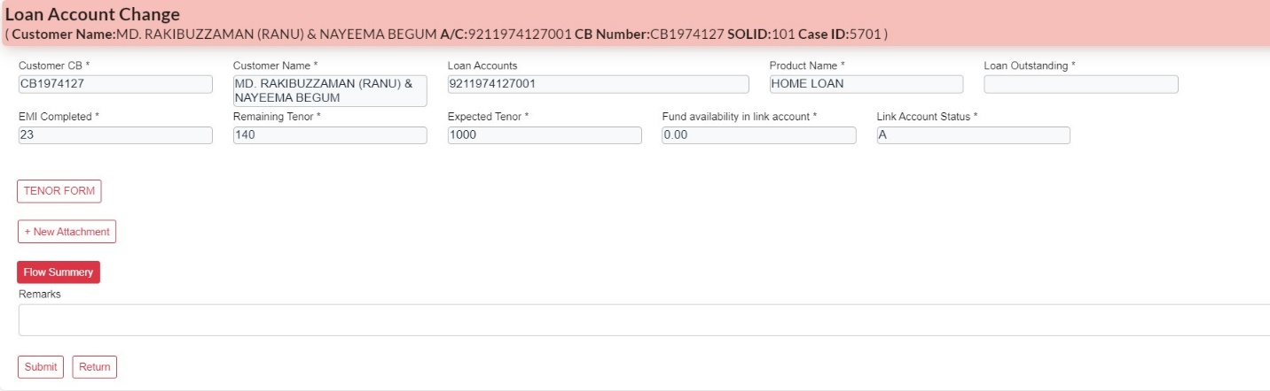In **Disbursement Checker** end user can forward or return the case. When user click **Return** then the case will returned to Disbursement maker or click **Submit** button then the case will be successfully completed.

**EMI Date Change**

After login in the system with required ID and Password user will select EMI Date Change request from the service request type.

**CS View**

To initiate the case, User need to input CB (Customer unique number) to generate other require information.

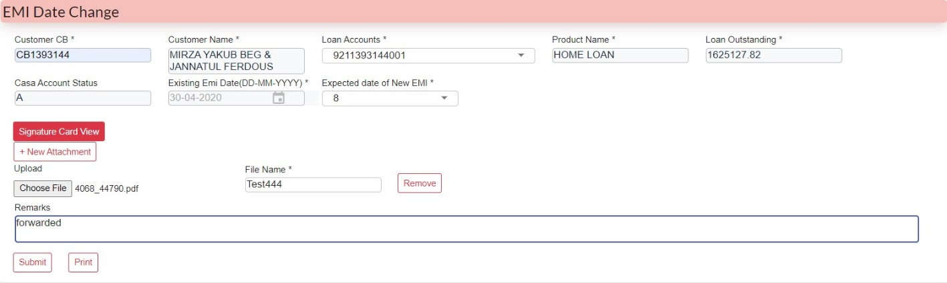Here, user can view signature card, can add attachment and Print client details, after fill-up all the required fields. Click **Submit** button to forward the case from **CS to BM**

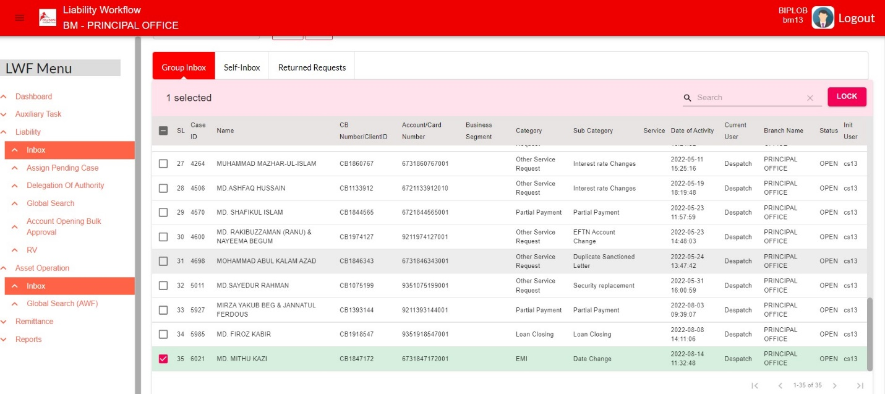After Logged in **BM**, Case will be found at Branch Inbox Need to lock the case from **Group Inbox** then the case will be open from **Self-Inbox**



**BM View**

**In BM end,** here user can attach file and view/download fileif **BM** Click **Submit** button then the case will be forwarded to **Disbursement Maker** flow, if click **Return** then the case returned to **CS**

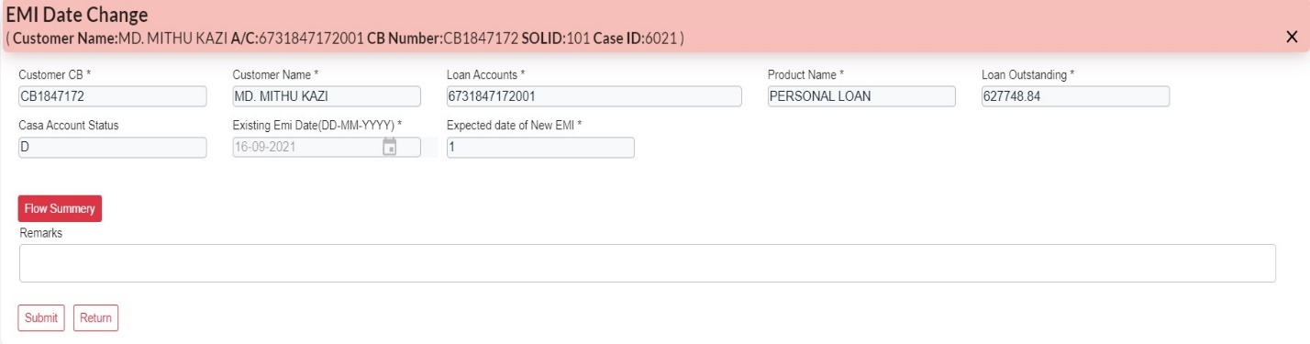

**Closing Maker view**

After logged in **Closing Maker** with the ID & Password, Same as **BM** procedure, lock the case from Group Inbox and open it from Self Inbox.

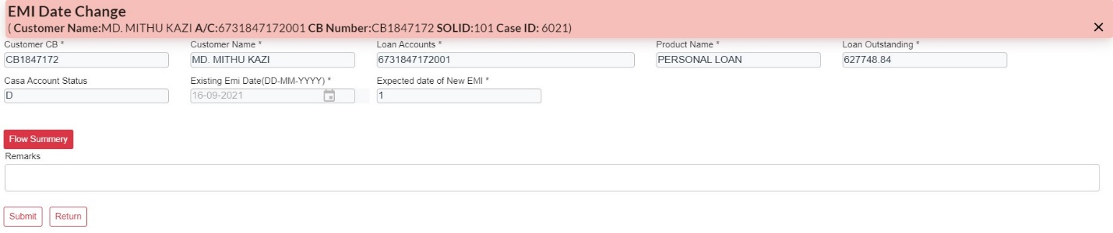In Closing maker end user can add new attachment and after clicking **Submit** button user can forward the case to **Closing Checker** or **Return** the case to **CS.**

**Closing Checker view**

After logged in **Closing Checker** with the ID & Password, Same as **BM** procedure, lock the case from Group Inbox and open it from Self Inbox.

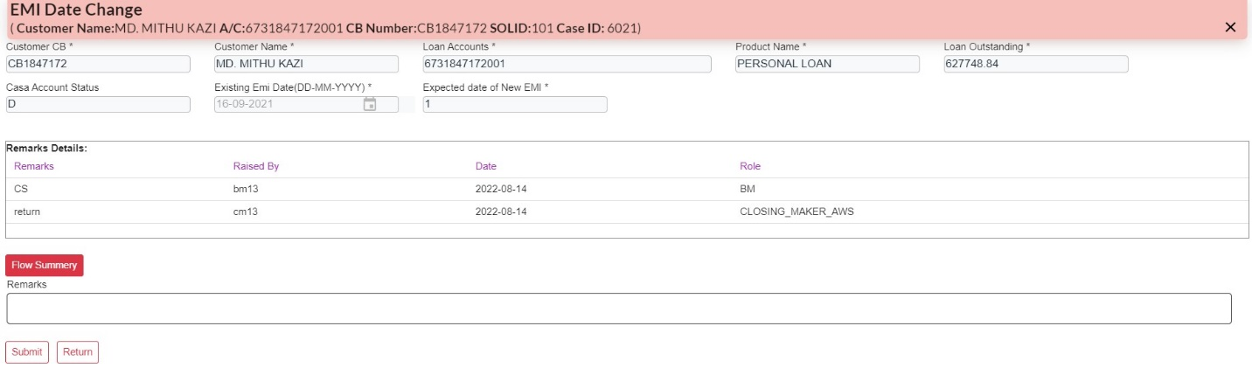In **Closing Checker** end user can forward or return the case. When user click **Return** then the case will returned to closing maker, if user click **Submit** button then the case will be successfully completed.



**Other Service Request**

**Interest transfer request**

**Security replacement**

**Partial Security release**

**EFTN Account Change**

**Interest rate Changes**

**Link account Changes**

**Duplicate NOC**

**Duplicate Sanctioned Letter**

**Interest transfer request**

After clicking **Service Request** user will get a dropdown bar. From there user can select AWF Service Request Type- **Other Service Request.** Then input **CB number** in respective customer CB field and choose required request type from the dropdown.

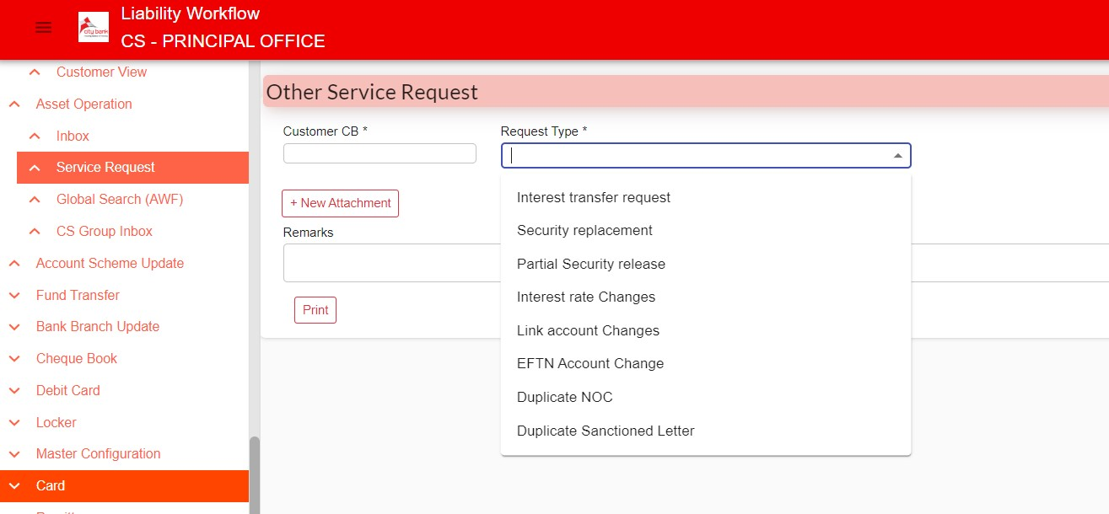

**CS View**

To initiate the case, User need to select loan account from dropdown to generate other require information. User can add attachment and Print client details. User can add respective remarks then Click **Submit** button to forward the case from **CS to BM.**

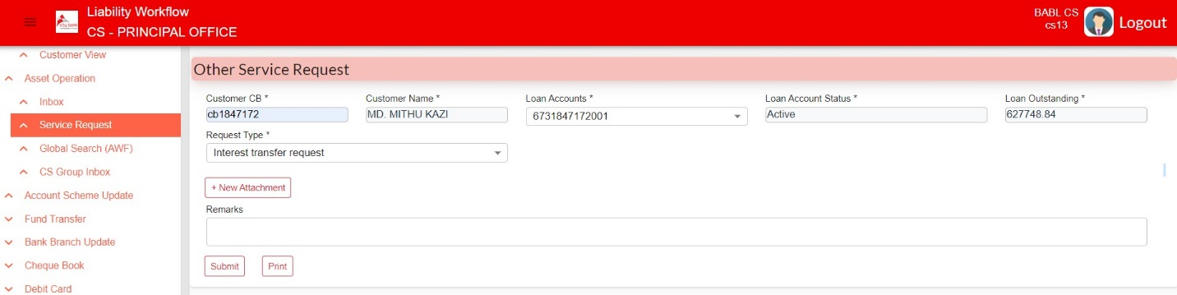

**BM View**

After logged in with user ID and password, user will get the case in group inbox. Locked the case to open it from self-inbox.

**In BM end,** here user can attach file and view/download fileif **BM** Click **Submit** button then the case will be forwarded to **Closing Maker** flow, if click **Return** then the case returned to **CS**

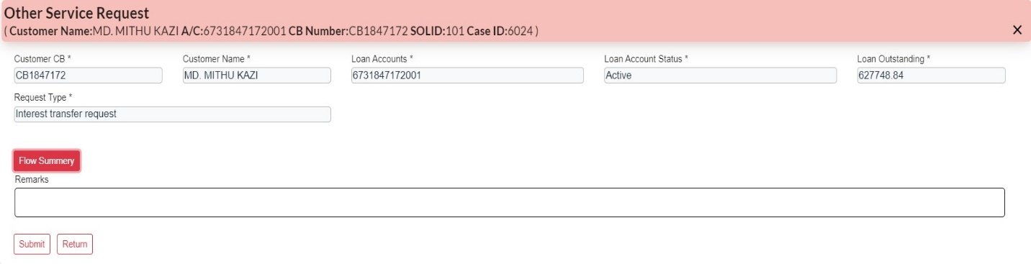

**Closing Maker View**

After logged in **Closing Maker** with the ID & Password, Same as **BM** procedure, lock the case from Group Inbox and open it from Self Inbox.

****In Closing maker end user can add new attachment, check flow summary, add remarks and after clicking **Submit** button user can forward the case to **Closing Checker** or **Return** the case to **CS.**

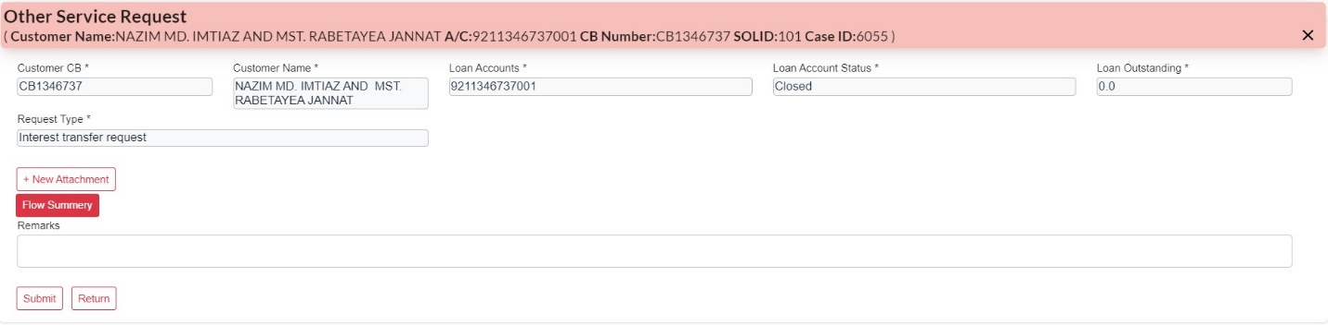



**Closing Checker View**

After logged in **Closing Checker** with the ID & Password, Same as **BM** procedure, lock the case from Group Inbox and open it from Self Inbox.

****In **Closing Checker** end user can validate the case. When user click **Return** then the case will returned to closing maker, if user click **Submit** button then the case will be successfully completed.



**System Login**

For starting the Asset workflow process, Firstly user **CR** (Collection Representative) User have a login ID from Admin user. User will login with respective Login ID. Sample page are given below. User need to Input respective user ID and Password in User ID and Password field. Click on Sign In button.

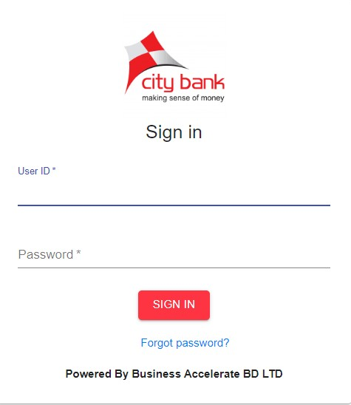

After login these Page will appear. We have to click **Asset Operation** and then **Service Request.**

After clicking **Service Request** user will get a dropdown bar. From there user can select AWF Service Request Type

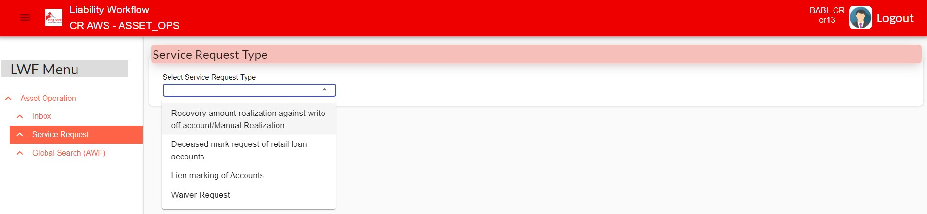



**Deceased mark request of retail loan accounts**

**CR View**

To initiate the case, User need to input CB (Customer unique number) to generate other require information.

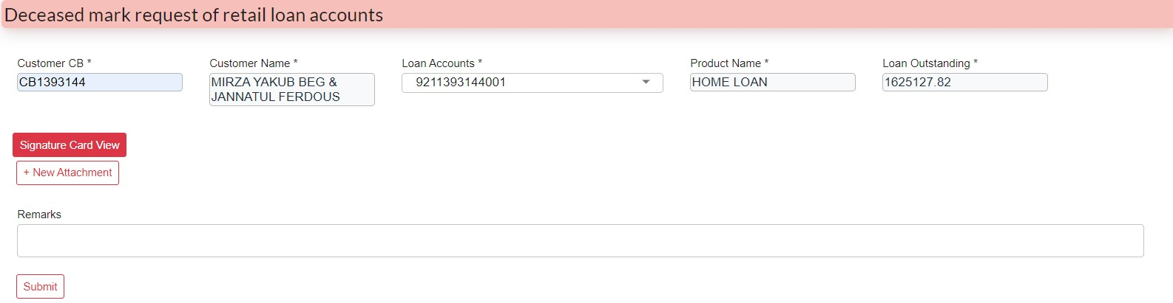Here, user can view signature card and can add attachment. Then user need to Click **Submit** button to forward the case from **CR to Collection Manager.**

**Collection Manager View**

After Logged in **Collection Manager**, Case will be found at Branch Inbox Need to lock from **Group Inbox** then the case will be open from **Self-Inbox**

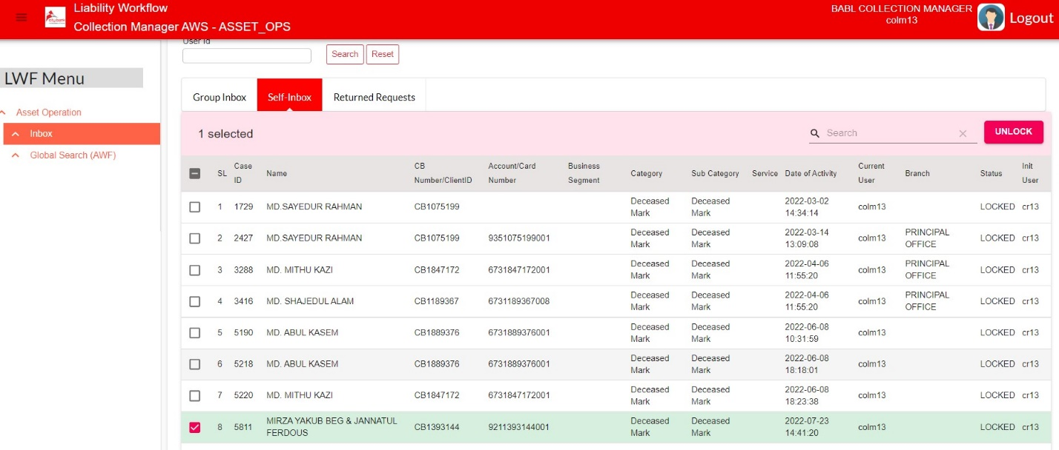



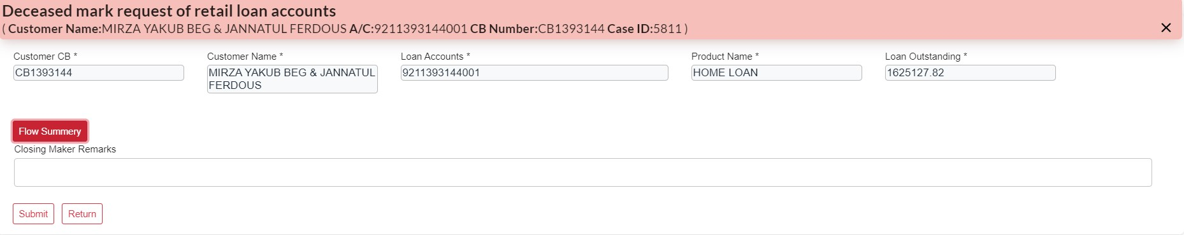If **Collection Manager** Click **Submit** button then the case will be forwarded to **Closing Checker** flow, If click **Return** then the case returned to **CR**

**Closing Maker**

After login in **Closing maker** with respective ID and Password, user will get the case at group inbox then lock the case to open it from self inbox. Here user can check the **flow summary**, can give remarks and then forward the case to Closing Checker, If any rectification needed then user can return the case to **CR**

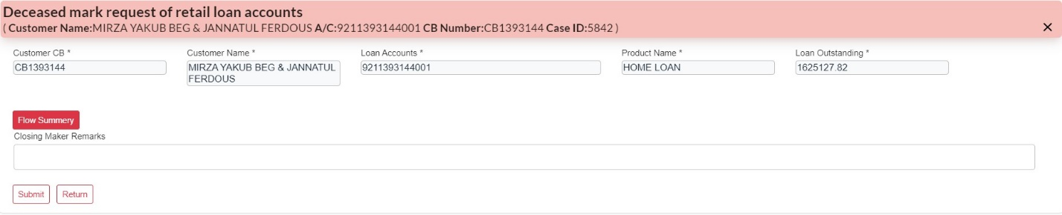



**Closing Checker View**

User have to logging in with respective Id and password. User will get the case in group inbox and then lock the case to open it from self inbox. Here user can check flow summary, give remarks. If User click Submit button then the case will be successfully completed, if need any rectification then user need to click Return button to return the case to Closing Maker returned inbox.

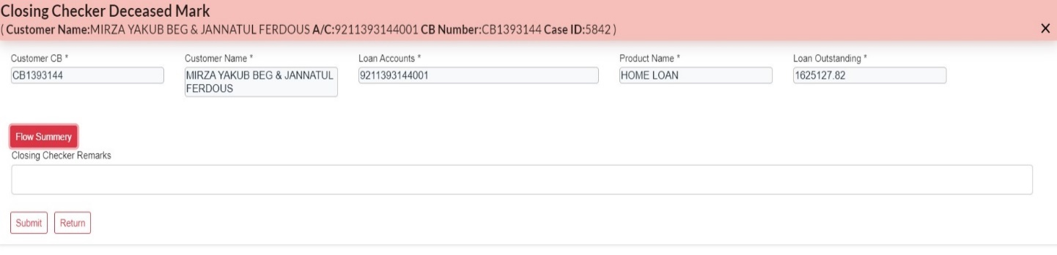

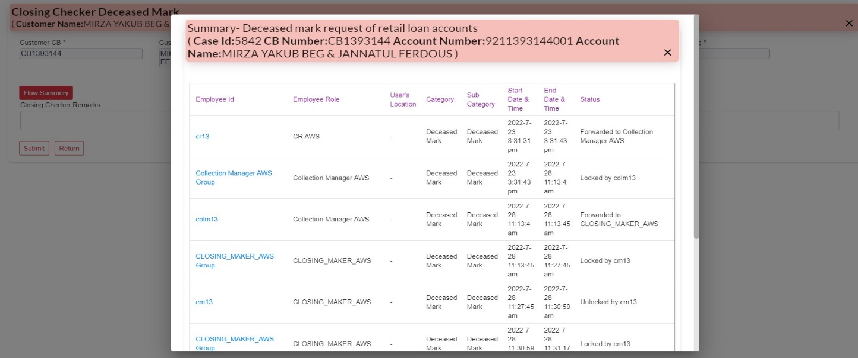



**Lien Marking**

After login in the system with required ID and Password user will select **Lien Making of Accounts** request from the service request type.

**CR View**

To initiate the case, User need to input CB (Customer unique number) to generate other require information.

Here, user can add attachment and fill-up required information. Then user need to Click **Submit** button to forward the case from **CR to Closing Maker**

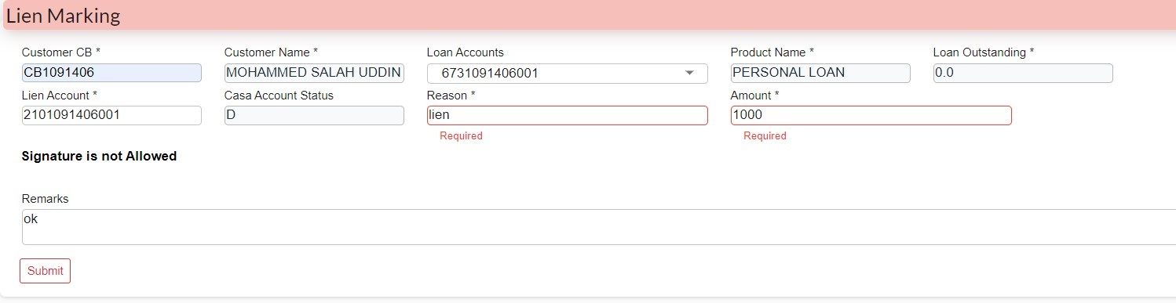

**Closing Maker View**

After logged in **Closing** **Maker** with the ID & Password, lock the case from Group Inbox and open it from Self Inbox.

****In **Closing** **Maker** end user can add remarks if user click **Submit** thenthe case will forward to **Closing Checker** if user click **Return** then the case returned to **CR.**

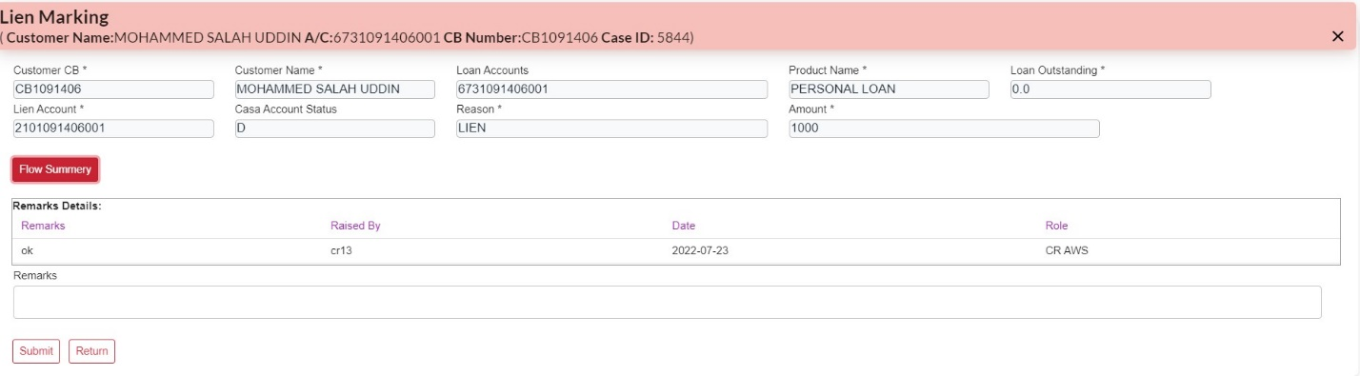

**Closing Checker View**

After logged in **Closing** **Checker** with the ID & Password, lock the case from Group Inbox and open it from Self Inbox.

****In **Closing** **Checker** end user can check flow summary add remarks if user click **Submit** thenthe case will be Successfully Completed or If **Return** then the case then it will returned to **CR.**

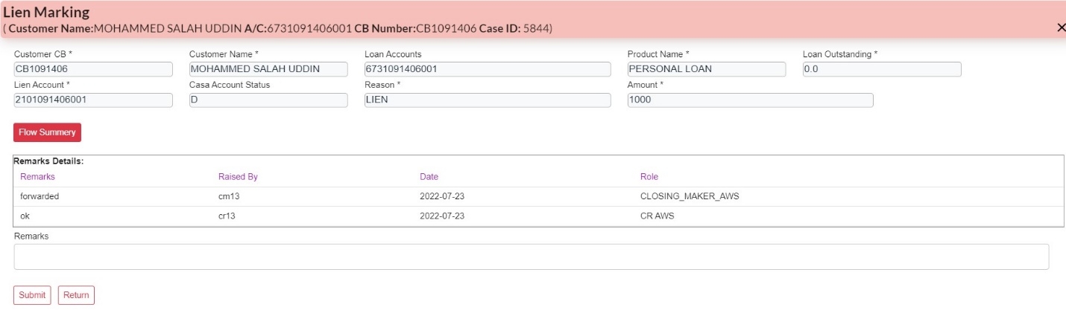

**Waiver Request**

After login in the system with required ID and Password user will select **Waiver Request** from the service request type.

**CR View**

To initiate the case, User need to input CB (Customer unique number) to generate other require information.

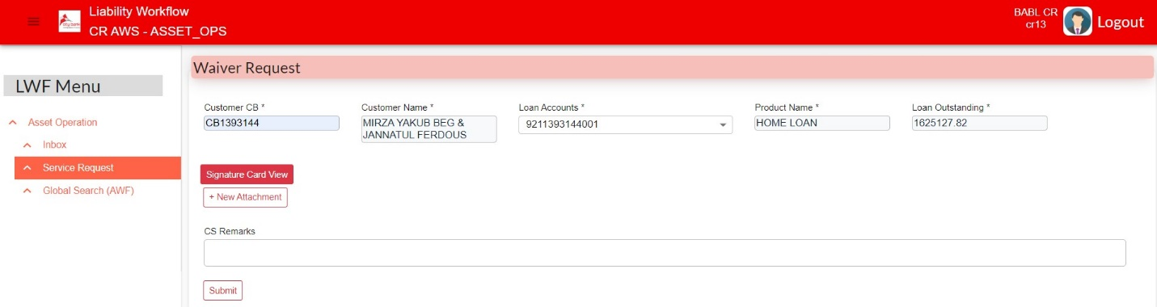Here, user can add attachment and fill-up required information. Then user need to Click **Submit** button to forward the case from **CR to Closing Maker**

Submit

**Closing Maker View**

After logged in **Closing** **Maker** with the ID & Password, lock the case from Group Inbox and open it from Self Inbox.

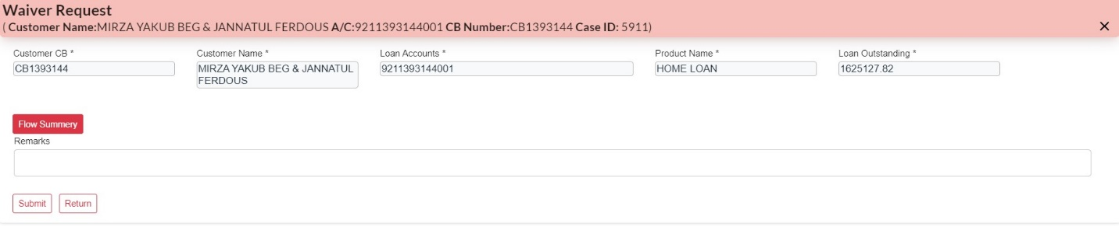In **Closing** **Maker** end user can add remarks if user click **Submit** thenthe case will forward to **Closing Checker** if user click **Return** then the case returned to **CR.**

**Closing Checker View**

After logged in **Closing** **Checker** with the ID & Password, lock the case from Group Inbox and open it from Self Inbox.

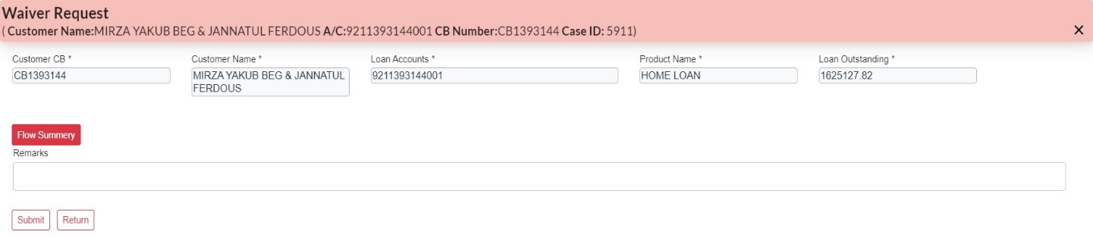In **Closing** **Checker** end user can check flow summary add remarks if user click **Submit** thenthe case will be forwarded to **NOC Maker** or If **Return** then the case then it will returned to **Closing Maker.**

**NOC Maker View**

After logged in **NOC Maker** with the ID & Password, Same as **BM** procedure, lock the case from **Group Inbox** and open it from **Self Inbox.**

In **NOC Maker** end user can add attachment and Print NOC letter. After Clicking **Submit** button case will be forward to NOC Checker. If user click return then the case will returned to closing

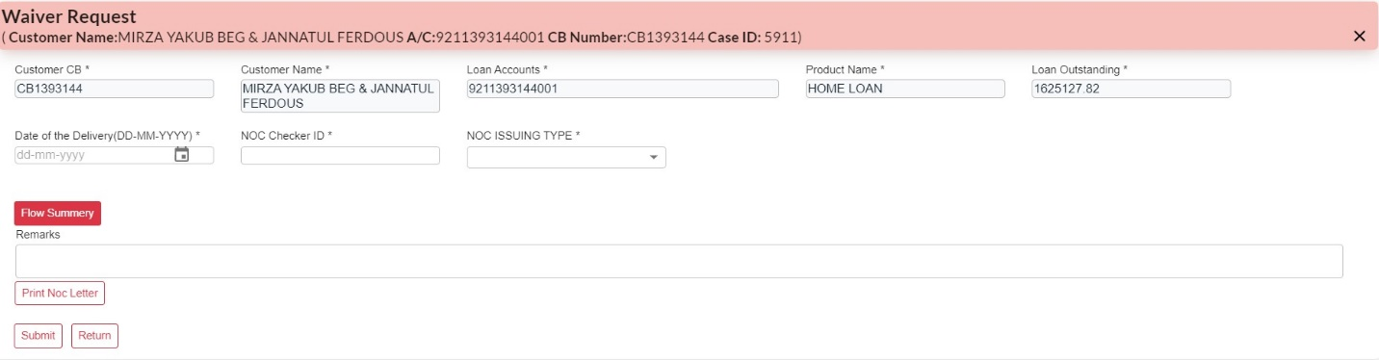

Print NOC Letter

**NOC Checker View**

After logged in **NOC Checker** with the ID & Password, Same as **BM** procedure, lock the case from **Group Inbox** and open it from **Self Inbox.**

In **NOC Maker** end user can add attachment and Print NOC letter. After Clicking **Submit** button case will be successfully completed.

If user click Return then the case will be returned to NOC Makers return inbox.



